PATHWELL CONNECT™ Protocol Series
The Ghost Attribution Layer (GHOST.ATTR)
A Technical Whitepaper on Privacy-Preserving Monetization

AnchorTrust Holdings LLC

Executive Summary
In the emerging Attribution Economy, a fundamental paradox exists: organizations possess valuable intellectual property that could generate revenue through reuse and collaboration, yet they cannot risk exposing their competitive advantages or trade secrets. The Ghost Attribution Layer (GHOST.ATTR) resolves this paradox by enabling selective attribution visibility—allowing contributors to monetize their most valuable assets while maintaining complete control over what information is revealed, to whom, and under what circumstances.
GHOST.ATTR is not a compromise between privacy and profitability—it proves these goals are fully compatible. Organizations can participate in a shared orchestration economy, earn revenue from component reuse, and collaborate with competitors, all while keeping their proprietary logic, algorithms, and implementation details completely hidden.
This whitepaper demonstrates how GHOST.ATTR:
- Solves the IP Dilemma: Enables monetization of proprietary components without source code exposure
- Enables Competitive Collaboration: Allows fierce competitors to co-exist in a shared ecosystem while protecting core advantages
- De-risks Enterprise Adoption: Makes the Attribution Economy enterprise-ready by addressing IP protection concerns from day one

1. The Intellectual Property Dilemma

1.1 The Core Problem
Modern enterprises face an impossible choice when considering participation in AI orchestration platforms and automation marketplaces:
Option A: Share Everything
- Contribute valuable automation components, AI models, and business logic to gain network effects
- Risk: Expose proprietary algorithms, competitive differentiators, and trade secrets
- Outcome: Unacceptable IP leakage, competitive disadvantage
Option B: Share Nothing
- Protect all intellectual property by remaining isolated
- Risk: Miss revenue opportunities, network effects, and ecosystem benefits
- Outcome: Competitive disadvantage through isolation
Current Reality: Most enterprises choose Option B, limiting market growth and preventing the emergence of truly collaborative AI ecosystems.

1.2 Why Traditional Attribution Fails
Conventional attribution systems operate on binary logic:
- Full Visibility: Complete authorship details exposed to all participants
- No Visibility: Anonymous contributions with no creator recognition or compensation
Neither model serves enterprise needs:
Approach | IP Protection | Monetization | Trust Building | Compliance
Full Attribution | Exposed | Possible | Strong | Risky
Anonymous | Protected | Impossible | None | Fails Audit
GHOST.ATTR | Protected | Enabled | Preserved | Maintained

1.3 Real-World Examples of the Dilemma
Example 1: AI Model Providers A company develops a proprietary AI model for fraud detection with 99.7% accuracy. They could monetize this model in a shared marketplace, but doing so would reveal:
- Model architecture and hyperparameters
- Training methodologies
- Proprietary feature engineering
- Domain-specific optimizations
With GHOST.ATTR: The model can be used, monetized, and compensated without exposing any implementation details.
Example 2: System Integrators A systems integrator creates sophisticated orchestration logic connecting multiple enterprise systems. This logic represents years of refinement and competitive advantage, yet they want to offer it as a service to clients without revealing:
- Integration patterns and best practices
- Error handling strategies
- Performance optimization techniques
- Client-specific customizations
With GHOST.ATTR: They can offer the service, earn per-usage fees, and maintain complete opacity on implementation.
Example 3: Pharmaceutical Research A pharmaceutical company develops AI-driven drug discovery workflows that identify promising compounds. They need to collaborate with research institutions while protecting:
- Proprietary screening algorithms
- Molecular modeling techniques
- Research methodologies
- Preliminary findings
With GHOST.ATTR: Collaboration occurs with full attribution tracking and revenue distribution, but implementation details remain confidential.

2. Technical Architecture of GHOST.ATTR

2.1 Core Components
The Ghost Attribution Layer consists of four primary object classes within the Multi-Tier Configuration Architecture (MTCA™):

GHOST.ATTR [1454] - Ghost Attribution Policies
Defines attribution visibility rules by tenant, role, or jurisdiction. Core capabilities:
- Full Suppression: Complete anonymization of creator identity
- Redacted Fields: Selective masking of specific attribution metadata
- Time-Bound Exposure: Temporary visibility with automatic expiration
- Zero-Trust Masking: Context-aware visibility based on trust levels

GHOST.ATTR.SCOPE [1455] - Attribution Scope Conditions
Declarative controls determining when and where attribution metadata is revealed:
- Entity trust level requirements
- Jurisdictional boundaries
- Workflow ID restrictions
- Economic tier prerequisites
- Compliance policy alignment

GHOST.ATTR.OVERRIDE [1456] - Override Disclosure Rules
Enables sovereign or contractual enforcement to override ghost status in regulatory contexts:
- DNS-linked override registries (e.g., sovereignagi.ai)
- Judicial authorization requirements
- Disclosure audit trails
- Emergency attribution revelation
- Tenant opt-in visibility escalation

GHOST.ATTR.MONETIZE [1457] - Hidden Revenue Routing
Routes attribution revenue even when attribution is not externally visible:
- Ghost monetization tracking
- Encrypted payment routing
- AUTH.OBJ [1376] integration
- Economic enforcement without identity exposure
- Cryptographic proof of contribution

2.2 How GHOST.ATTR Works
The Ghost Attribution system operates through a sophisticated visibility and enforcement mechanism:
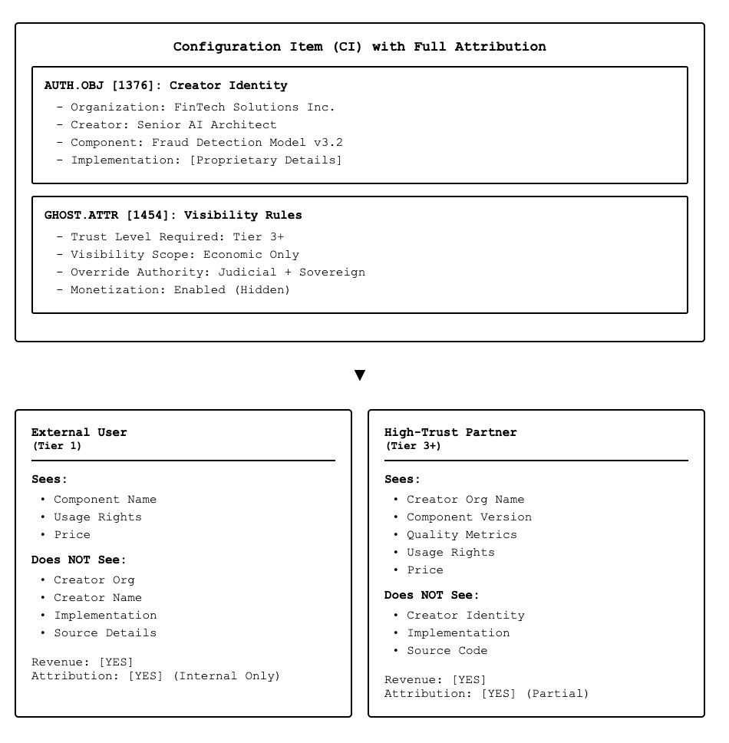
Key Technical Mechanisms:
- Layered Attribution Storage: Full attribution exists in AUTH.OBJ [1376] but visibility is mediated through GHOST.ATTR policies
- Context-Aware Filtering: Runtime evaluation determines what metadata to reveal based on requester context
- Economic Decoupling: Revenue routing operates independently from attribution visibility
- Cryptographic Enforcement: Zero-knowledge proofs enable verification without disclosure
- Audit Compliance: Complete audit trails maintained while preserving operational opacity
Receipt-compatible privacy. GHOST emits privacy-preserving receipts that satisfy the system’s audit and settlement rails without exposing sensitive internals. Each operation produces a Dispatch Receipt and an Execution Receipt with the minimum public fields required for governance (policy_hash, policy_origin, jurisdiction, reason_codes, nonce, expires_at) while binding all private attribution (creators, weights, routing) via cryptographic commitments. Selective-disclosure and zero-knowledge proofs attest that hidden values meet policy (e.g., jurisdictional constraints, attribution sum = 100%) without revealing them. On failure, a Denial Receipt is emitted; the denial is itself signed and linkable to the attempted operation.

2.3 Integration with Economic Enforcement
ECON.ROY interoperability (hardware-agnostic). GHOST receipts expose just enough evidence for settlement to be deterministic across heterogeneous hardware—GPUs, photonic, thermodynamic, even quantum—while keeping proprietary internals ghosted. Execution emits: measured_energy_j, normalized_energy_per_unit, grams_co2e_per_kwh, variance_pct, and measurement_confidence. Private beneficiary splits stay hidden behind commitments; the engine applies operator-only efficiency adjustments per ECON.ROY §7.1 and verifies that hidden splits still sum to 100% using a range-proof/commitment scheme. If policy or evidence is stale (STALE_POLICY, DEGRADED_FRESHNESS), GHOST tags the receipt; bonuses/penalties are suppressed without disclosing hidden structure (see ECON.ROY §7.1 for efficiency adjustments and settlement determinism).
To enable privacy-preserving monetization, GHOST.ATTR integrates with the Economic Tier (ECON) objects:
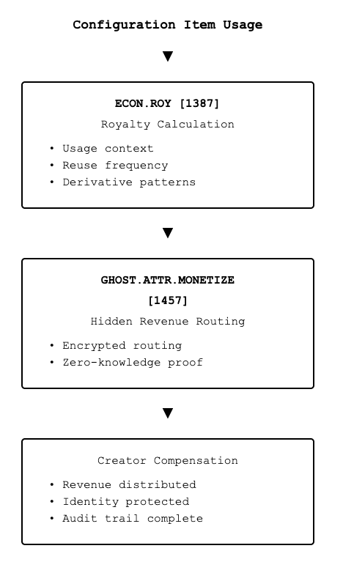
Economic Enforcement Without Identity Disclosure:
- ECON.TAX [1386]: Platform tax applied regardless of attribution visibility
- ECON.TRUST.SCORE [1388]: Trust validation operates on cryptographic proofs, not identity
- ECON.ESC [1391]: Escrow management supports ghost participants
- ECON.ATTR [1389]: Attribution routing maintains confidentiality while ensuring compensation
Settlement is fail-closed: absence of a valid Dispatch→Execution chain or CRL hits denies disbursement; quarantine escrows funds until revalidation.

2.4 Trust Without Full Disclosure
A critical innovation of GHOST.ATTR is enabling trust and verification without full attribution visibility:
Trust Building Mechanisms:
- Cryptographic Signatures: Prove component authenticity without revealing creator
- Reputation Proxies: Trust scores based on historical performance, not identity
- Third-Party Attestation: Independent verification of quality without creator exposure
- Behavioral Analytics: Component behavior serves as trust indicator
- Sovereign Validation: Government entities can verify without public disclosure
Example Trust Flow:
Component X used 10,000 times
├─ Success Rate: 99.8%
├─ Performance: 150ms avg latency
├─ Compliance: 100% adherence
├─ Trust Score: 4.9/5.0
└─ Creator: [PROTECTED BY GHOST.ATTR]

→ Users trust the component based on verifiable performance
→ Creator remains anonymous while building reputation
→ Revenue flows to creator automatically
→ System maintains audit trails for compliance

3. Business Value Proposition

3.1 Solving the IP Dilemma
For Contributors (IP Owners):
Monetize Without Exposure
- Earn revenue from component reuse while protecting implementation
- Participate in network effects without sacrificing competitive advantage
- Generate passive income from proprietary automation assets
Control Information Flow
- Define exactly what metadata is visible to whom
- Adjust visibility policies based on trust relationships
- Maintain complete control over IP exposure
Build Market Presence
- Establish reputation through performance, not identity
- Demonstrate value through usage metrics
- Create brand recognition with controlled disclosure
For Consumers (Component Users):
Access Premium Components
- Utilize enterprise-grade automation without vendor lock-in
- Benefit from best-in-class solutions previously unavailable
- Pay only for usage, not for ownership
Trust Through Performance
- Make decisions based on verified metrics, not marketing claims
- Access quality indicators without needing internal knowledge
- Rely on cryptographic proofs and sovereign validation
Compliance Confidence
- Participate in auditable systems with full compliance
- Meet regulatory requirements without compromising partners
- Maintain sovereign oversight capabilities

3.2 Enabling Competitive Collaboration
GHOST.ATTR creates unprecedented opportunities for competitors to collaborate within the same ecosystem:
Scenario: Banking Industry Collaboration
Traditional Model | GHOST.ATTR Model
Each bank builds fraud detection independently | Banks contribute anonymously to shared fraud detection network
No component sharing due to competitive concerns | Components shared with full IP protection
Massive duplication of effort | Reduced development costs through selective reuse
Slower innovation cycles | Faster innovation through collective intelligence
Zero revenue from reuse | Per-use compensation for valuable components
How It Works:
- Bank A develops sophisticated fraud detection logic → contributes with GHOST.ATTR protection
- Bank B uses the component → sees only performance metrics, not source
- Bank A receives per-use compensation → maintains competitive advantage
- Bank C contributes complementary component → creates virtuous cycle
- All banks benefit from network effects → without exposing unique methodologies
Real Business Impact:
- Development Cost Reduction: 40-60% savings through selective component reuse
- Time-to-Market: 3-5x faster deployment using proven, trusted components
- Revenue Generation: New income streams from existing IP assets
- Innovation Acceleration: Focus resources on genuine differentiators

3.3 De-Risking Enterprise Adoption
Key Enterprise Concerns Addressed:

Concern 1: "We can't expose our AI models to competitors"
GHOST.ATTR Solution: Models remain completely opaque while generating revenue. Competitors can use your model without seeing architecture, weights, or training data.

Concern 2: "Our integration patterns are our competitive advantage"
GHOST.ATTR Solution: Orchestration logic visibility is controlled by trust tier. Only authorized partners see implementation details, others see only interface specifications.

Concern 3: "Regulatory compliance requires attribution trails"
GHOST.ATTR Solution: Full audit trails maintained internally with sovereign override capabilities. Compliance teams have complete visibility while operational systems remain protected.

Concern 4: "We need attribution for legal liability"
GHOST.ATTR Solution: Legal attribution persists in AUTH.OBJ [1376] with contractual override mechanisms. Judicial authorities can pierce the ghost layer when legally required.

Concern 5: "How do we trust anonymous components?"
GHOST.ATTR Solution: Trust through cryptographic proofs, performance history, sovereign validation, and reputation systems—not through identity disclosure.

3.4 Economic Model
Revenue Opportunities:
- Direct Monetization
  - Per-use fees for component execution
  - Subscription models for high-frequency users
  - Tiered pricing based on trust level access
- Indirect Value Creation
  - Reduced development costs through selective reuse
  - Faster time-to-market leveraging proven components
  - Enhanced reputation through performance metrics
- Network Effects
  - Value multiplies as more participants join
  - Ecosystem becomes more valuable with each contribution
  - Recursive yield through component composition
Typical Economic Flow:
Component Used
│
├─→ 5-7% Platform Tax (ECON.TAX [1386])
│
├─→ 70-80% Creator Revenue (ECON.ROY [1387])
│
└─→ 10-15% Infrastructure / Escrow (ECON.ESC [1391])

Creator receives revenue automatically
Identity remains protected
Trust score improves with usage
Platform sustainability ensured

4. Use Cases and Applications

4.1 AI Model Marketplaces
Scenario: Machine Learning Model Monetization
Challenge: AI companies want to monetize proprietary models but cannot risk exposing model architecture, training data, or fine-tuning techniques to competitors or reverse engineering.
GHOST.ATTR Implementation:
- Models deployed with complete implementation opacity
- Users access via API without visibility into internals
- Performance metrics (accuracy, latency, cost) publicly visible
- Creator identity optionally hidden or selectively revealed
- Per-inference billing with automatic royalty distribution
Benefits:
- For Model Creators: Monetize IP without exposure, build reputation through performance
- For Users: Access state-of-the-art models without procurement complexity
- For Platform: Vibrant marketplace with premium IP protected

4.2 Enterprise System Integration
Scenario: Multi-Party Business Process Automation
Challenge: System integrators develop sophisticated orchestration patterns connecting ERP, CRM, and supply chain systems. These patterns represent years of refinement but clients need integration capabilities without vendor lock-in.
GHOST.ATTR Implementation:
- Integration patterns contributed with selective visibility
- High-trust partners see architectural patterns
- Regular users see only interface specifications
- Implementation details remain completely hidden
- Revenue generated per orchestration execution
Benefits:
- For Integrators: Protect methodologies while scaling delivery
- For Enterprises: Access proven patterns without vendor dependency
- For Ecosystem: Reduced duplication, faster implementation

4.3 Pharmaceutical Research Collaboration
Scenario: Drug Discovery AI Workflows
Challenge: Pharmaceutical companies need to collaborate on AI-driven drug discovery while protecting proprietary screening algorithms, molecular modeling techniques, and research methodologies.
GHOST.ATTR Implementation:
- Research workflows shared with multi-tier visibility
- Academic partners see research protocols
- Competing pharma companies see only aggregated results
- Regulatory bodies have full override access
- Contribution tracking for IP licensing
Benefits:
- For Pharma Companies: Accelerate research while protecting competitive advantage
- For Research Institutions: Access industry-grade tools
- For Regulators: Full transparency when required

4.4 Financial Services Fraud Detection
Scenario: Collaborative Fraud Prevention Network
Challenge: Financial institutions benefit from shared fraud intelligence but cannot expose detection algorithms, risk models, or customer data patterns.
GHOST.ATTR Implementation:
- Fraud detection components contribute to shared network
- Each institution's algorithms remain confidential
- Aggregate fraud patterns visible to all participants
- Individual contributions tracked for compliance
- Revenue sharing based on contribution value
Benefits:
- For Financial Institutions: Enhanced fraud detection without IP exposure
- For Customers: Better protection through collective intelligence
- For Regulators: Visibility into network effectiveness

4.5 Government and Defense Applications
Scenario: Multi-Agency Intelligence Orchestration
Challenge: Government agencies need to share automation capabilities across agencies and with allied nations while maintaining classification levels and operational security.
GHOST.ATTR Implementation:
- Classification-aware visibility controls
- Allied nations access capabilities without seeing implementation
- Sovereign override for national security authorities
- Full audit trails for accountability
- Zero-trust architecture with cryptographic enforcement
Benefits:
- For Agencies: Share capabilities without compromising methods
- For Allies: Access advanced tools while respecting sovereignty
- For Oversight: Complete transparency for authorized personnel

5. Implementation Considerations

5.1 Technical Requirements
Core Infrastructure:
- Multi-Tier Configuration Architecture (MTCA™)
  - 31 canonical tiers supporting attribution and governance
  - Configuration items as first-class digital assets
  - Recursive inheritance and policy enforcement
- Attribution Object System (AUTH.OBJ [1376])
  - Complete creator identity and lineage tracking
  - Licensing metadata and usage rights
  - Cryptographic signatures and certificates
- Economic Enforcement Layer (ECON Tier)
  - Automated royalty calculation and distribution
  - Platform tax enforcement
  - Escrow and compliance management
- Trust Infrastructure (TRUST Tier)
  - Cryptographic trust scoring
  - Performance-based reputation
  - Sovereign validation mechanisms
Implementation Complexity:
- Low Complexity: Basic ghost attribution for simple components
- Medium Complexity: Multi-tier visibility with trust-based access
- High Complexity: Full sovereign integration with regulatory override

5.2 Organizational Readiness
Prerequisites for Adoption:
Legal and Compliance
- IP ownership clearly defined
- Licensing terms established
- Regulatory requirements understood
- Audit procedures documented
Technical Capabilities
- API integration capacity
- Cryptographic infrastructure
- Monitoring and analytics
- Security operations
Business Processes
- Component valuation methodology
- Revenue accounting procedures
- Partner management systems
- Dispute resolution protocols

5.3 Security and Privacy
Security Mechanisms:
- Cryptographic Protection
  - Zero-knowledge proofs for contribution verification
  - Encrypted revenue routing
  - Tamper-evident audit logs
  - Sovereign key management
- Access Control
  - Role-based visibility policies
  - Trust-tier requirements
  - Temporal access restrictions
  - Emergency override procedures
- Privacy Preservation
  - Differential privacy for aggregate metrics
  - K-anonymity for contributor pools
  - Homomorphic computation where applicable
  - Privacy-preserving audit trails
Compliance Frameworks:
- GDPR compliance for EU operations
- CCPA compliance for California
- HIPAA compliance for healthcare
- SOC 2 Type II certification
- FedRAMP authorization for government

Confidential attestation. Dual-source energy validation (device sensor vs. controller estimate) is enforced while protecting signal values: the device publishes a commitment to its measured energy and a range proof that the controller-recomputed variance is below the policy threshold; only the variance flag (pass/fail) is public. When variance exceeds threshold, the adapter DENIES and emits VARIANCE_EXCEEDED without leaking raw numbers.
`carbon_confidence` and `measurement_confidence` reveal only confidence weights, not underlying data sources or raw measurements.
Unlinkability & pseudonyms. GHOST rotates per-invocation pseudonymous keys and salts commitments so receipts cannot be cross-linked to reconstruct hidden attribution. Authorization is proven with anonymous credentials; identity is revealed only under GHOST.ATTR.OVERRIDE conditions.
Revocation & replay. Receipts include nonce and expires_at; reuse or post-expiry yields REPLAY_DETECTED. Keys/devices on the registry CRL trigger KEY_REVOKED / DEVICE_REVOKED. QUARANTINE mode escrow economics until revalidation (see Sovereign Override v2 §3 for enforcement outcomes and §6 for CRL propagation).

5.4 Governance and Policy
Policy Framework Requirements:
Policy anchoring. All GHOST decisions bind to compiled policy via policy_hash and declare policy_origin (e.g., SOV.POL[1446]:eu-ai-act-v1), enabling sovereign-aware audits without exposing hidden attribution internals.
- Attribution Policies (GHOST.ATTR [1454])
  - Default visibility levels
  - Trust tier definitions
  - Override authorization procedures
  - Dispute resolution mechanisms
- Economic Policies (ECON Tier)
  - Platform tax rates
  - Royalty distribution formulas
  - Escrow management rules
  - Revenue sharing agreements
- Sovereign Policies (SOV Tier)
  - Jurisdictional compliance requirements
  - Override authority definitions
  - Cross-border data handling
  - National security protocols
Governance Bodies:
- Technical Committee: Architecture and standards
- Economic Committee: Pricing and revenue models
- Compliance Committee: Regulatory alignment
- Dispute Resolution Board: Conflict arbitration

5.5 Migration Strategy
Phased Adoption Approach:
Phase 1: Internal Adoption (3-6 months)
- Deploy within single organization
- Test with non-critical components
- Validate technical infrastructure
- Train internal teams
Phase 2: Trusted Partner Extension (6-12 months)
- Extend to existing trusted partners
- Establish bilateral agreements
- Refine visibility policies
- Measure economic impact
Phase 3: Ecosystem Participation (12-24 months)
- Join broader attribution economy
- Contribute to public marketplaces
- Accept components from ecosystem
- Optimize monetization strategies
Phase 4: Full Integration (24+ months)
- Complete MTCA™ implementation
- Advanced sovereign integration
- Recursive yield optimization
- Ecosystem leadership position

6. Competitive Analysis

6.1 Comparison with Existing Approaches
Approach | IP Protection | Monetization | Trust Model | Compliance | Enterprise Ready
Open Source | None | Minimal | Reputation | Variable | Risky
API Marketplaces | Limited | Good | Platform-based | Basic | Partial
Private Licensing | Strong | Limited Scale | Contractual | Strong | Slow
GHOST.ATTR | Complete | Automatic | Cryptographic | Comprehensive | Native

6.2 Why GHOST.ATTR is Different
Unique Advantages:
- Constitutional Privacy: Privacy and attribution enforcement built into the execution fabric, not added as an afterthought
- Economic Decoupling: Revenue flows independently from visibility, enabling monetization without exposure
- Sovereign Integration: Native support for government oversight, regulatory compliance, and national security requirements
- Cryptographic Trust: Trust based on verifiable proofs and performance, not just reputation or identity
- Recursive Yield: Value multiplies through component composition while maintaining attribution integrity
- Policy Flexibility: Granular control over visibility at individual, organizational, jurisdictional, and temporal levels

7. Future Directions

7.1 Advanced Capabilities
Emerging Features:
- Adaptive Visibility Policies
  - Machine learning-based trust assessment
  - Dynamic policy adjustment based on context
  - Predictive access control
- Federated Learning Integration
  - Model training without data exposure
  - Collaborative improvement with privacy
  - Differential privacy guarantees
- Quantum-Safe Cryptography
  - Post-quantum encryption algorithms
  - Long-term privacy guarantees
  - Future-proof security architecture
- Autonomous Policy Negotiation
  - AI-driven visibility agreements
  - Smart contract enforcement
  - Self-optimizing economic terms
Ghost over heterogeneous hardware. GHOST normalizes evidence across compute_class (deterministic, probabilistic, quantum) using the hardware registry’s calibration factors. Receipts carry compute_class and the same public carbon fields. Hidden inference cost models and routing heuristics remain ghosted; settlement still computes fair, comparable energy/CO₂e per work-unit, independent of the underlying accelerator.
Work-unit abstraction (optional). When models emit vectors instead of tokens, GHOST records semantic_bandwidth_k, latent_codec_id, and sampler_calls privately, proving equivalence to policy’s pricing unit via zero-knowledge—so economics stay apples-to-apples without revealing model plumbing.

7.2 Ecosystem Evolution
Growth Opportunities:
- Industry-Specific Implementations
  - Healthcare: HIPAA-compliant ghost attribution
  - Finance: SEC-compliant trading algorithm protection
  - Defense: Classification-aware capability sharing
  - Manufacturing: Trade secret protection in supply chains
- Geographic Expansion
  - EU GDPR alignment
  - China data sovereignty compliance
  - ASEAN cross-border orchestration
  - African Union economic integration
- Vertical Integration
  - Edge computing and IoT devices
  - Satellite and space-based systems
  - 5G/6G network orchestration
  - Quantum computing resources

7.3 Research Directions
Open Questions:
- How can ghost attribution support emergent AGI systems while maintaining human oversight?
- What are optimal economic models for recursive value distribution in multi-tier ghost networks?
- How should dispute resolution work when all parties maintain attribution opacity?
- What cryptographic primitives best balance verifiability with privacy in high-stakes environments?

8. Conclusion

8.1 Key Takeaways
GHOST.ATTR fundamentally transforms the economics of IP contribution by proving that privacy and profitability are not mutually exclusive. Organizations can now:
✅ Monetize their most valuable intellectual property without exposing trade secrets or competitive advantages
✅ Collaborate with competitors in shared ecosystems while maintaining strategic differentiation
✅ Build trust through performance rather than identity disclosure
✅ Comply with regulatory requirements while preserving operational security
✅ Participate in network effects without sacrificing control or autonomy

8.2 The Path Forward
For Technology Buyers and Decision Makers:
The Attribution Economy powered by GHOST.ATTR represents a paradigm shift from binary choices (share everything or share nothing) to granular, policy-driven control over IP exposure.
This is not a future possibility—it's an enterprise-ready capability today that addresses the single biggest barrier to ecosystem participation: the fear of IP leakage.
Strategic Imperatives:
- Evaluate Current IP Exposure: Assess which assets could generate revenue if properly protected
- Pilot GHOST.ATTR Implementation: Start with non-critical components to validate the model
- Develop Visibility Policies: Define trust tiers and disclosure rules aligned with business strategy
- Measure Economic Impact: Track monetization, cost reduction, and innovation acceleration
- Scale to Ecosystem: Extend proven model to full ecosystem participation

8.3 Final Perspective
The question is no longer "Should we participate in the Attribution Economy?"
The question is: "Can we afford NOT to?"
Organizations that embrace privacy-preserving monetization will:
- Generate new revenue streams from existing IP
- Reduce development costs through selective reuse
- Accelerate innovation through collaborative intelligence
- Build sustainable competitive advantages in ecosystem participation
Organizations that hesitate will:
- Miss revenue opportunities from valuable IP assets
- Continue duplicating effort unnecessarily
- Fall behind in innovation cycles
- Lose market position to more adaptive competitors
GHOST.ATTR makes the Attribution Economy enterprise-ready from day one.
The technology exists. The architecture is proven. The economic model is sound.
The only question remaining is: When will you join?

Appendix: Technical Reference

Key Object Classes
GHOST.ATTR [1454] - Ghost Attribution Policies
- Defines attribution visibility rules
- Supports full suppression, redaction, time-bound exposure
- Enables ghost monetization
GHOST.ATTR.SCOPE [1455] - Attribution Scope Conditions
- Declarative visibility controls
- Trust level and jurisdictional scoping
- Workflow and economic tier restrictions
GHOST.ATTR.OVERRIDE [1456] - Override Disclosure Rules
- Sovereign and contractual enforcement
- DNS-linked override registries
- Judicial authorization mechanisms
GHOST.ATTR.MONETIZE [1457] - Hidden Revenue Routing
- Routes revenue with protected attribution
- AUTH.OBJ [1376] integration
- Cryptographic proof of contribution
AUTH.OBJ [1376] - Attribution Object
- Creator identity and lineage
- Licensing and usage metadata
- Cryptographic signatures
ECON.ROY [1387] - Economic Royalty
- Automated royalty calculation
- Usage-based compensation
- Recursive value distribution
ECON.TAX [1386] - Economic Tax
- Platform tax enforcement
- Jurisdictional compliance
- Infrastructure sustainability
ECON.TRUST.SCORE [1388] - Economic Trust Score
- Trust validation for participants
- Performance-based reputation
- Access control enforcement
TRUST.VAULT [1396] - Trust Vault
- Immutable audit trails
- Cryptographic verification
- Compliance recording
Receipt Privacy Integration
- GHOST receipts handled via GHOST.ATTR.MONETIZE [1457]
- Full receipt schemas defined in Master Receipt & Enforcement v1.0
- Privacy-preserving Dispatch/Execution/Denial receipts with selective disclosure
- Cryptographic commitments for private attribution (creators, weights, routing)
- JSON MUST be canonicalized (deterministic key ordering, normalized whitespace/encoding) prior to hashing/signing to ensure signature replay across implementations.
Zero-Knowledge Proofs (ZK.OBJ [1525])
- Privacy-preserving constraint proofs for GHOST attribution
- Proves: (a) attribution sum = 100%; (b) jurisdiction constraints satisfied; (c) variance below threshold; (d) floor/cap guarantees
- Enables verification without revealing private beneficiary splits or routing heuristics
- Supports transcript binding to receipt IDs to prevent misuse
Hardware-Agnostic Reason Codes
- CARBON_POLICY_BREACH, MISSING_DATA_PROVENANCE, STALE_POLICY, DEGRADED_FRESHNESS, VARIANCE_EXCEEDED, RECEIPT_CHAIN_INCOMPLETE, REPLAY_DETECTED, KEY_REVOKED, DEVICE_REVOKED
- Appear in reason_codes[] on Dispatch/Execution/Denial receipts
- Enable hardware-agnostic enforcement across compute classes
- Codes inherit categories used across the stack (POLICY, SECURITY, SYSTEM, VALIDATION) for uniform audit filtering.
Common Receipt Fields (Cross-Document Interoperability)
- Policy context: policy_origin, policy_hash, jurisdiction, reason_codes[]
- Anti-replay: nonce, expires_at, prev_receipt_hash
- Optional: agent_id, grid_region_proof, human_attestation
- Dispatch-specific: grams_co2e_per_kwh, carbon_confidence
- Execution-specific: measured_energy_j, normalized_energy_per_unit, grams_co2e_per_kwh, variance_pct, measurement_confidence, settlement_adjustment_bps
- Full OpenAPI specifications in Master Receipt & Enforcement v1.0

Related Technologies
- Multi-Tier Configuration Architecture (MTCA™): 31 canonical tiers for orchestration governance
- YACHT™: Yet Another Configuration Hierarchy Tier - execution framework
- GHOSTNET™: Attribution enforcement and selective visibility framework
- ATTRIBUTION ECONOMY™: Economic substrate for monetizable component reuse

Contact and Resources
For Implementation Inquiries: Contact AnchorTrust Holdings LLC Patent Reference: U.S. Provisional Patent Application, October 12, 2025 Technical Documentation: PATHWELL CONNECT™ platform documentation Domain References:
- attributioneconomy.ai
- ghostattribution.ai
- sovereignagi.ai
- nationalaiinfrastructure.com

This whitepaper is based on the Multi-Tier Configuration Architecture (MTCA™) and PATHWELL CONNECT™ platform as described in U.S. Patent Application by AnchorTrust Holdings LLC. GHOST.ATTR, GHOSTNET, ATTRIBUTION ECONOMY, MTCA, YACHT, and PATHWELL CONNECT are trademarks of AnchorTrust Holdings LLC.
© 2025 AnchorTrust Holdings LLC. All rights reserved.

